Statistics: The Science of Decisions

**Background Information:**

In a Stroop task, participants are presented with a list of words, with each word displayed in a color of ink. The participant’s task is to say out loud the *color of the ink* in which the word is printed. The task has two conditions: a congruent words condition, and an incongruent words condition. In the *congruent words* condition, the words being displayed are color words whose names match the colors in which they are printed: for example RED, BLUE. In the *incongruent words* condition, the words displayed are color words whose names do not match the colors in which they are printed: for example PURPLE, ORANGE. In each case, we measure the time it takes to name the ink colors in equally-sized lists. Each participant will go through and record a time from each condition.

**Questions for Investigation:**

Q1. What is our independent variable? What is our dependent variable?

1. **Independent Variable:** It is the condition of the word set which is given to the participant i.e. Congruent words condition or Incongruent words condition.

**Dependent Variable:** It is the time the participant takes to name the ink colours. The time is measured for both the congruent words and incongruent words condition and compared. The number of words in the list during both the conditions is kept equal.

Q2. What is an appropriate set of hypotheses for this task? What kind of statistical test do you expect to perform? Justify your choices.

1. Set of hypotheses for this set would be:

**Null hypothesis -** H0: µcongruent = µincongruent

**Alternate hypothesis -** HA: µcongruent ≠ µincongruent

The ‘Null hypothesis’ states that the time taken to name the ink colours in the congruent words condition is equal to the time taken to name the colours in the incongruent words condition.

The ‘Alternate hypothesis’ states that there is a difference in the time taken to name the colours between the congruent condition and the incongruent condition.

**Statistical Test:** We do not have any knowledge about the population parameters so we will perform **t-test** (instead of z-test).

The t-test that we will perform is on the same set of people so the t-test will be **dependent sample** t-test.

Also we do not have any knowledge about the time that people will take in both the conditions so will perform a **two-tailed test** (not assuming that µcongruent should be less than µincongruent).

So we will perform a **two-tailed dependent sample t-test**.

Q3. Report some descriptive statistics regarding this dataset. Include at least one measure of central tendency and at least one measure of variability.

A. Descriptive Statistics along with the original data:

|  |  |  |
| --- | --- | --- |
| **Participant Number** | **Congruent** | **Incongruent** |
| 1 | 12.079 | 19.278 |
| 2 | 16.791 | 18.741 |
| 3 | 9.564 | 21.214 |
| 4 | 8.63 | 15.687 |
| 5 | 14.669 | 22.803 |
| 6 | 12.238 | 20.878 |
| 7 | 14.692 | 24.572 |
| 8 | 8.987 | 17.394 |
| 9 | 9.401 | 20.762 |
| 10 | 14.48 | 26.282 |
| 11 | 22.328 | 24.524 |
| 12 | 15.298 | 18.644 |
| 13 | 15.073 | 17.51 |
| 14 | 16.929 | 20.33 |
| 15 | 18.2 | 35.255 |
| 16 | 12.13 | 22.158 |
| 17 | 18.495 | 25.139 |
| 18 | 10.639 | 20.429 |
| 19 | 11.344 | 17.425 |
| 20 | 12.369 | 34.288 |
| 21 | 12.944 | 23.894 |
| 22 | 14.233 | 17.96 |
| 23 | 19.71 | 22.058 |
| 24 | 16.004 | 21.157 |
| **Measures of central tendency:** |  |  |
| Mean | 14.051125 | 22.01591667 |
| Median | 14.3565 | 21.0175 |
|  |  |  |
| **Measures of variability:** |  |  |
| Variance | 12.66902907 | 23.01175704 |
| Standard Deviation | 3.559357958 | 4.797057122 |

Q4. Provide one or two visualizations that show the distribution of the sample data. Write one or two sentences noting what you observe about the plot or plots.

A. Visualization of the data:

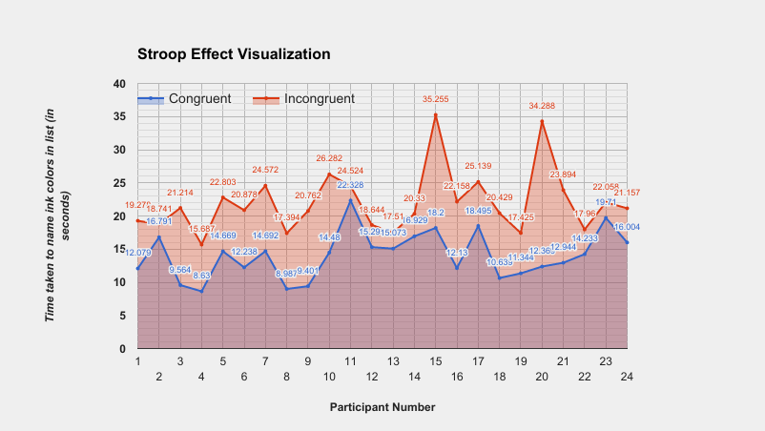

From the visualization above we can see that the time taken to name ink colors in the list is lower in case of congruent word list than the incongruent word list. But we need to perform a proper statistical analysis in order to confirm this as we know that correlation does not mean causation. Therefore we perform a **dependent sample two-tailed t-test**.

Q5. Now, perform the statistical test and report your results. What is your confidence level and your critical statistic value? Do you reject the null hypothesis or fail to reject it? Come to a conclusion in terms of the experiment task. Did the results match up with your expectations?

1. We will perform the t-test using **α=0.05** which is equivalent to a **95%** confidence interval. We know the number of observations as 24. Thus for **n=24** we get:

**Df (degrees of freedom) = 24-1 = 23**

**t-critical = ± 2.069**

t-value = (Xc-Xi)/(S/√n)

where ; Xc, Xi – mean of congruent and incongruent set respectively

S- standard deviation of differences

= (14.051125 - 22.01591667)/( 4.86482691/√24)

= -8.020706945

**t-value = -8.020706945**

The two-tailed **P value is less than 0.0001** thus our result is statistically significant.

Since the t-value (-8.020706945) is much lower than the t-critical value (-2.069) therefore we can **reject the null hypothesis**.

Q6.What do you think is responsible for the effects observed? Can you think of an alternative or similar task that would result in a similar effect?

1. An explanation could be that reading the word can be done subconsciously but recognising the color needs larger attention which increases the time to respond.

Other theories suggest that there is a lag in the brain's ability to recognize the color of the word since the brain reads words faster than it recognizes colors.

Another theory suggests that automatic reading does not need controlled attention, but still uses enough attentional resources to reduce the amount of attention accessible for color information processing.

Parallel distributed processing theory suggests that as the brain analyses information, different and specific pathways are developed for different tasks. Some pathways, such as reading, are stronger than others, therefore, it is the strength of the pathway and not the speed of the pathway that is important.

Other variations of the Stroop Test have been devised which have a similar effect as the Stroop effect. Some of these variations of Stroop tasks are warped word, emotional, spatial, numerical, reverse Stroop test.

Resources and Helps:

* Google Spread sheet for creating charts and visualizations - <https://drive.google.com/open?id=1qBOpkroyaLh652ReTu7aaf7--Nf32PRUpmGtDDVzAno>
* <https://graphpad.com/quickcalcs/pValue2/> - For calculating the P value
* <https://en.wikipedia.org/wiki/Stroop_effect> - For studying about Stroop effect and its different types